Screenshots of Acceptance Testcases

1. Several deposit or withdraw agent windows can be open and functioning on a single account.

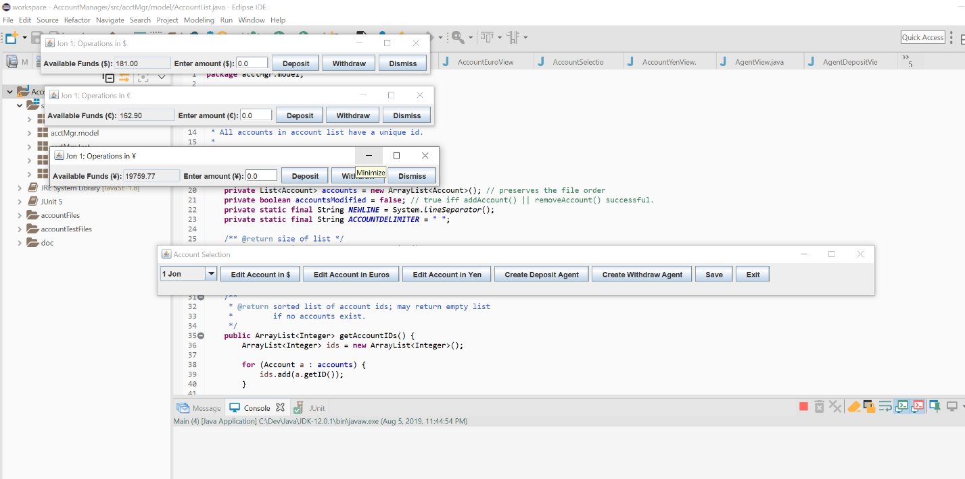

2. withdraw agents properly block if the balance is not enough for the withdraw amount.

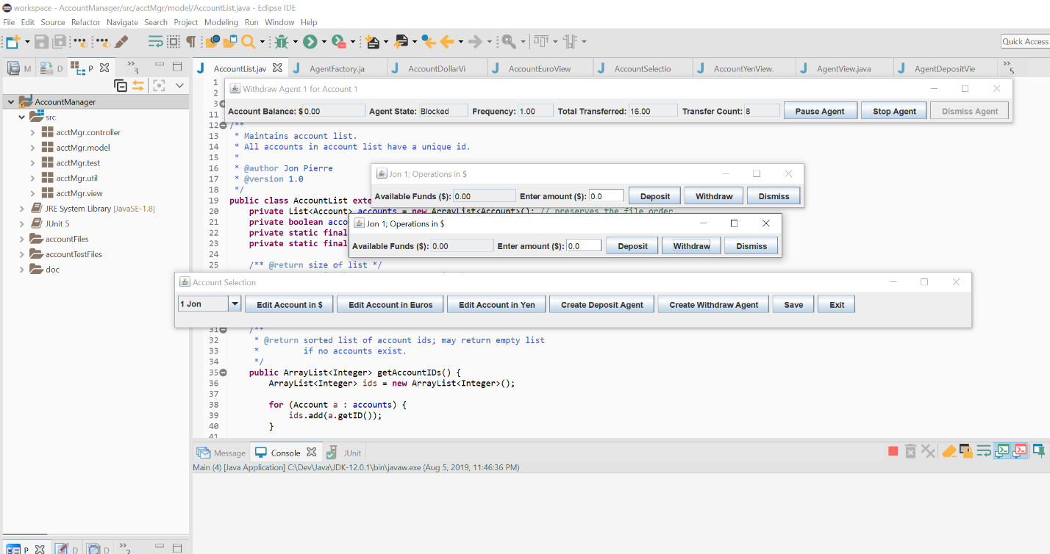

3. withdraw agents properly wake up from blocking if a sufficient amount is deposited into the balance on which they were blocked.

